# Automated Static Testing

## What is Automated Static Testing

**# Source**: **Chatgpt (GPT-5-Standard) at [8/14/2025]**

**Automated Static Testing** is a type of software testing where tools automatically examine **artifacts** (code, documents, models) *without executing the program* to find defects, inconsistencies, or violations of standards.

## Key Points

**# Source**: **Chatgpt (GPT-5-Standard) at [8/14/2025]**

* **Static** → The software is *not run*; the analysis is done on the code or documents as they are.
* **Automated** → The inspection is done by specialized software tools instead of humans manually reviewing.
* **Goal** → Detect defects early, reduce human review effort, and enforce coding/documentation standards.

## Examples

**# Source**: **Chatgpt (GPT-5-Standard) at [8/14/2025]**

1. **Static Code Analysis Tools**
   * Detect syntax errors, unused variables, dead code, security vulnerabilities, or performance issues.
   * Tools: **SonarQube**, **ESLint** (JavaScript), **Pylint** (Python), **Checkstyle** (Java).
2. **Automated Document Checks**
   * Verify completeness or formatting of requirements documents, test cases, or architecture diagrams.
   * Example: Requirements tools that auto-check for ambiguous words like *“quickly”* or *“user-friendly”*.
3. **Security Scanners**
   * Look for vulnerabilities like SQL injection risks, insecure dependencies, or missing encryption.
   * Tools: **OWASP Dependency-Check**, **Bandit** (Python security).

## Benefits

**# Source**: **Chatgpt (GPT-5-Standard) at [8/14/2025]**

* **Faster feedback** than manual reviews.
* Detects issues that humans may overlook.
* Can run continuously in a **CI/CD pipeline**.
* Reduces cost by catching problems early.

## Difference from Manual Static Testing

**# Source**: **Chatgpt (GPT-5-Standard) at [8/14/2025]**

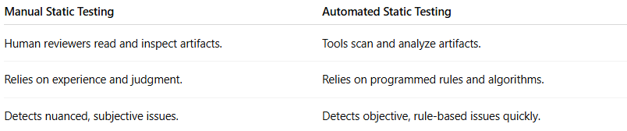

| **Manual Static Testing** | **Automated Static Testing** |
| --- | --- |
| Human reviewers read and inspect artifacts. | Tools scan and analyze artifacts. |
| Relies on experience and judgment. | Relies on programmed rules and algorithms. |
| Detects nuanced, subjective issues. | Detects objective, rule-based issues quickly. |